Leveling System (a short explanation)

The leveling system works as in the game “Vampire Survivors”. With every enemy kill the player gets XP (15xp per kill). Every time he levels up he will be promted with 3 random upgrades (see player upgrades below). He could, for example, have to choose between Attack Damage, Thrust and Health after his first level up. On his second level up he could choose between Attack Range, Thrust and Movement Speed and so on.
This way the player gets different options with every new game and has to strategize about the best way to go on depending on his options.
The leveling formula might have to be adjusted but I thought of something like this:

xpNeededToLevelUp = (currentLevel^1,15 * 100) * 1.1

At 15xp per kill the player would need to exponentially slay more enemies to increase his level. The XP needed would look like this (excluding decimals):

Level 1: 110
Level 2: 244
Level 3: 389
Level 4: 541
etc…

About the Leveling Interface:

When the player gets a level up he should be immediately promted with an in-game window with those 3 randomized options. Something like this:

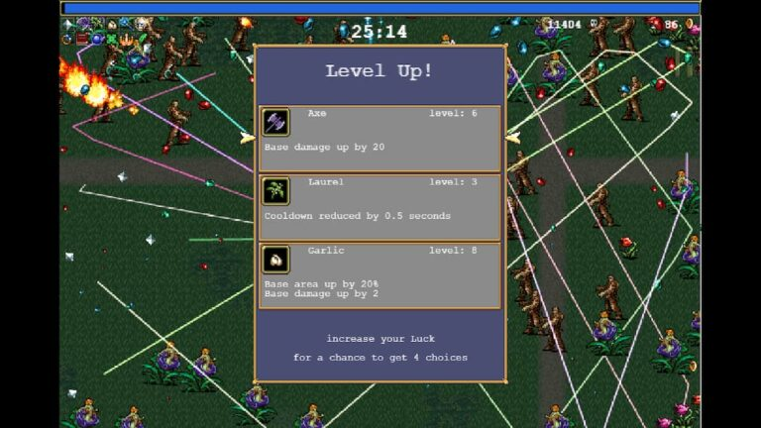
Time needs to stop while the player chooses his upgrade in order for him not to die while doing so and resume automatically once he made his choice. Also an xp-bar at the bottom of the screen to indicate how far the player has advanced towards the next level would be required.

Available Upgrades

Player:

Attack Damage:

12.5% Increase per Upgrade

Attack Range:

10% Increase per Upgrade

Thrust:

10% Increase per Upgrade

Attack Rate:

8% Decrease per Upgrade (When attack rate decreases the player can attack MORE often, that’s why it’s a decrease instead of an increase)

Movement Speed:

5% Increase per Upgrade

Health:

+1 Health per Upgrade

Enemies:

Per Level Up enemies get a 15% health increase. All the other stats stay the same.

